 

**Placement Empowerment Program**

***Cloud Computing and DevOps Centre***

*Create a storage bucket on your cloud platform and upload/download files. Configure access permissions for the bucket.*

Name: Arvindan S Department : ADS



**Introduction and Overview**

In this (PoC), we will explore AWS S3 (Simple Storage Service) to understand its functionality as a reliable cloud storage solution. The task involves creating an S3 bucket, uploading and downloading files, and configuring access permissions to manage who can access the stored data.

**Objective**

The goal of this project is to:

1. Understand AWS S3 Basics: Learn how to create, configure, and manage an S3 bucket for cloud storage.
2. File Operations: Gain hands-on experience in uploading, downloading, and managing files within the S3 bucket.
3. Access Control: Configure bucket policies and permissions to manage secure and public access to stored data.

**Importance of Storage Bucket(S3)**

**Foundation for Advanced Use Cases**: Learning how to handle S3 storage is a stepping stone for mastering cloud computing and deploying large-scale applications.

**Hands-On Learning of Cloud Storage**: AWS S3 provides a practical platform to learn cloud storage concepts, enabling users to create buckets, upload/download files, and manage data at scale.

**Data Security and Access Control**: By configuring bucket policies and permissions, users can secure their data and manage who can access it.

**Step-by-Step Overview**

Step1:

Go to the AWS Management Console, Search for and click on S3

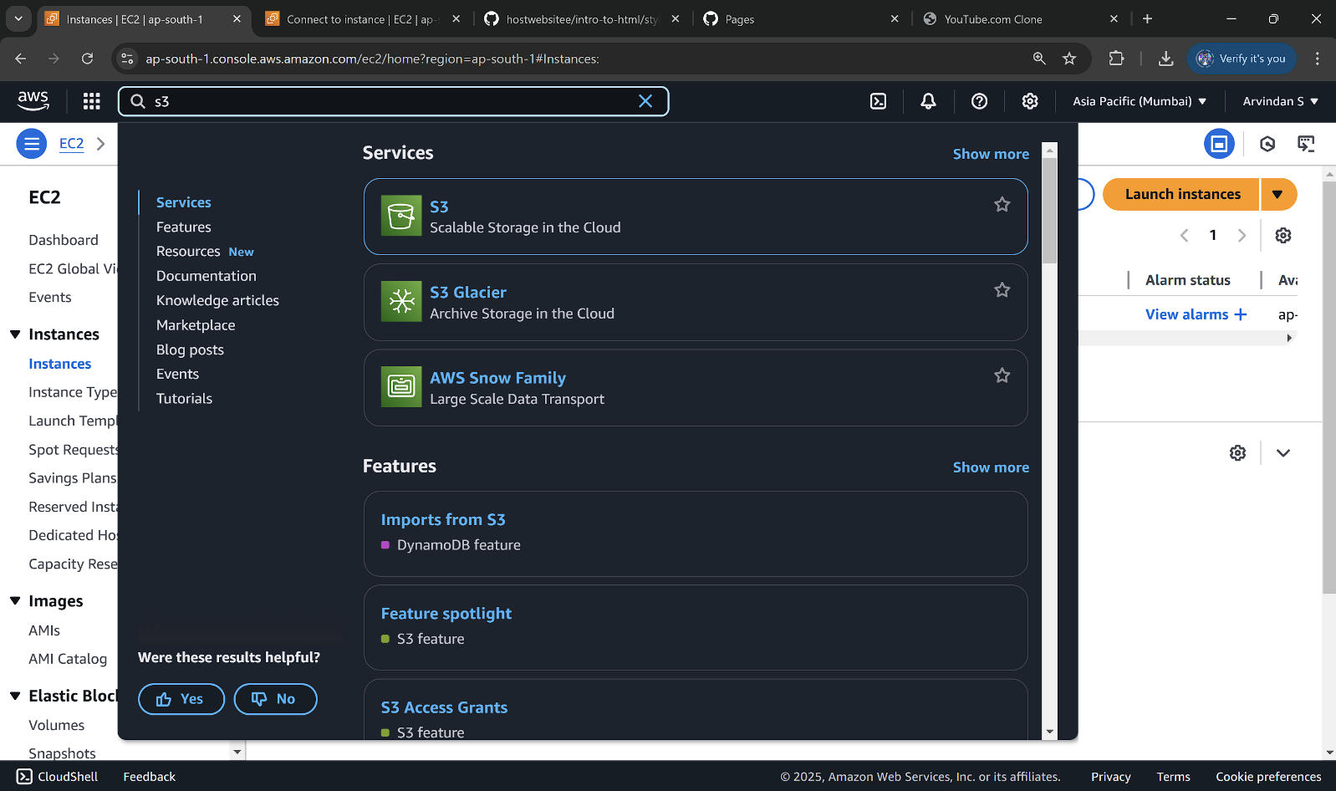

Step 2 :

Click the "Create bucket" button.

Enter a unique bucket name (e.g., my-storage-bucket-123).

Step 3 :

Leave "Block all public access" enabled for now (you can modify it later).

Step 4 :

Click "Create bucket".

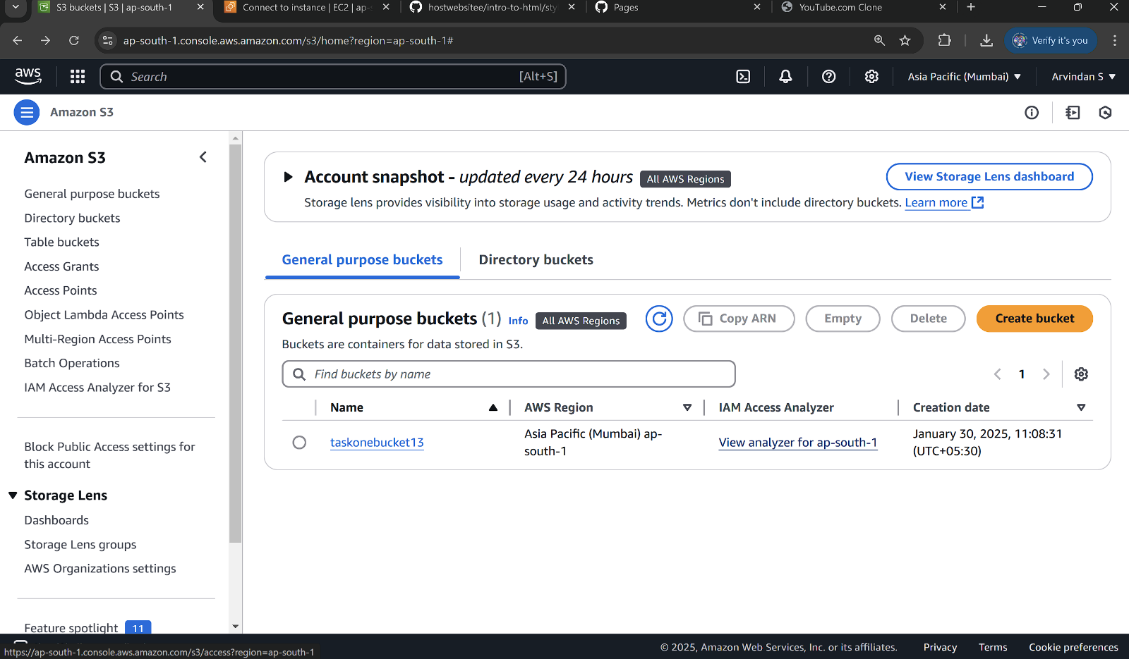

Step 5 :

Open your newly created bucket from the S3 console.

Step 6 :

Click "Upload" and then,

Drag and drop your file(s) or use the Add files button.Click Upload to complete.

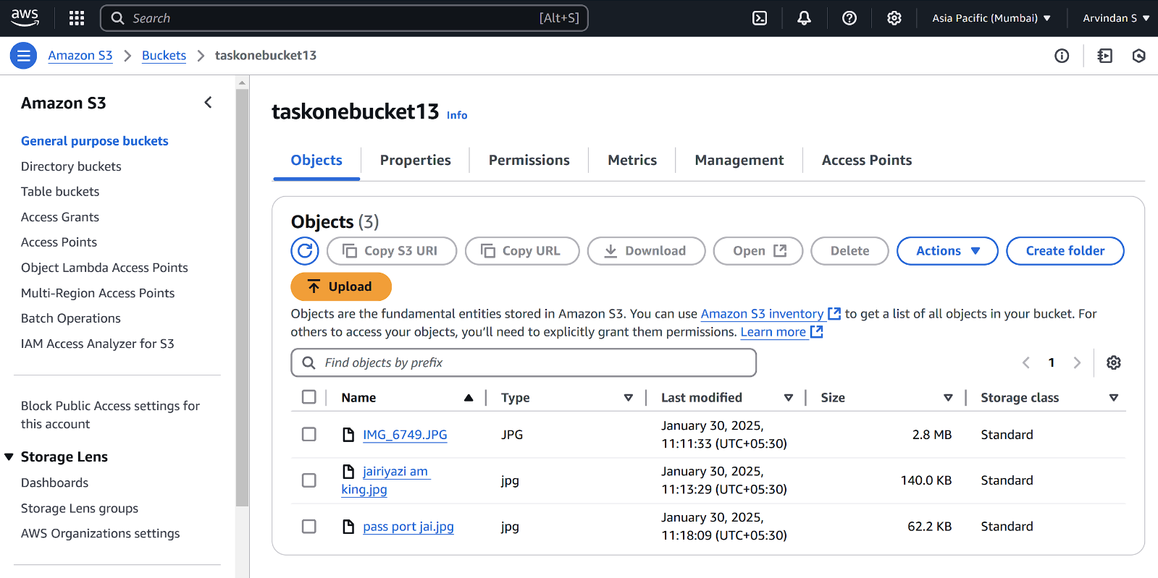

Step 7 :

Go to the uploaded file in your bucket. Click the file name to open its details. Select Download to save the file locally.

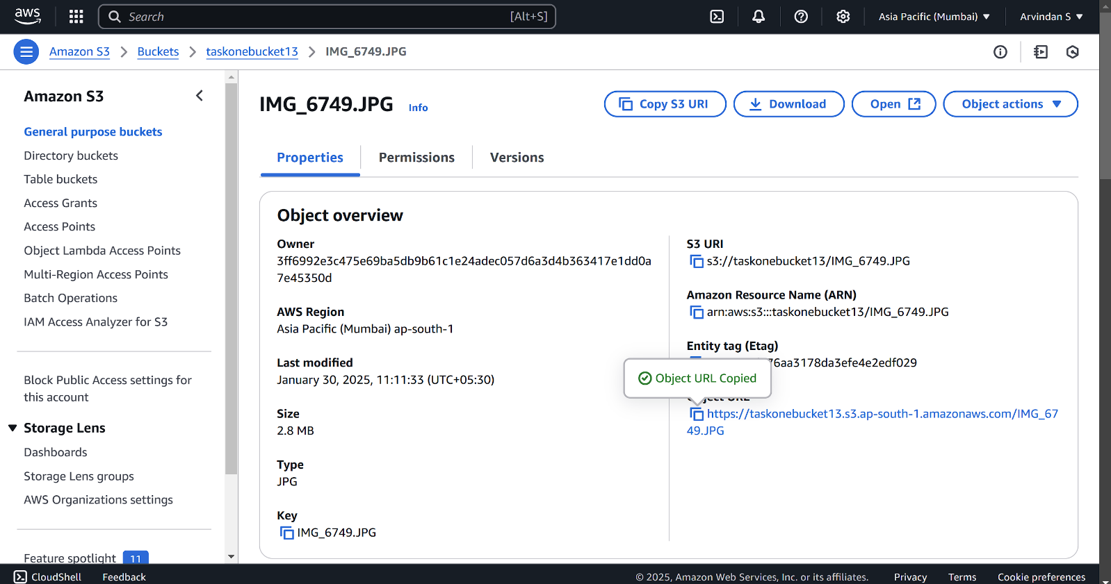

Step 8 :

Open your bucket and navigate to the "Permissions" tab.

Under Block public access, click Edit and uncheck "Block all public access". Confirm by typing "confirm" and save.

Step 9 :

In the "Permissions" tab, scroll to Bucket Policy and click Edit.Replace your-bucket-name with your actual bucket name.Save changes.

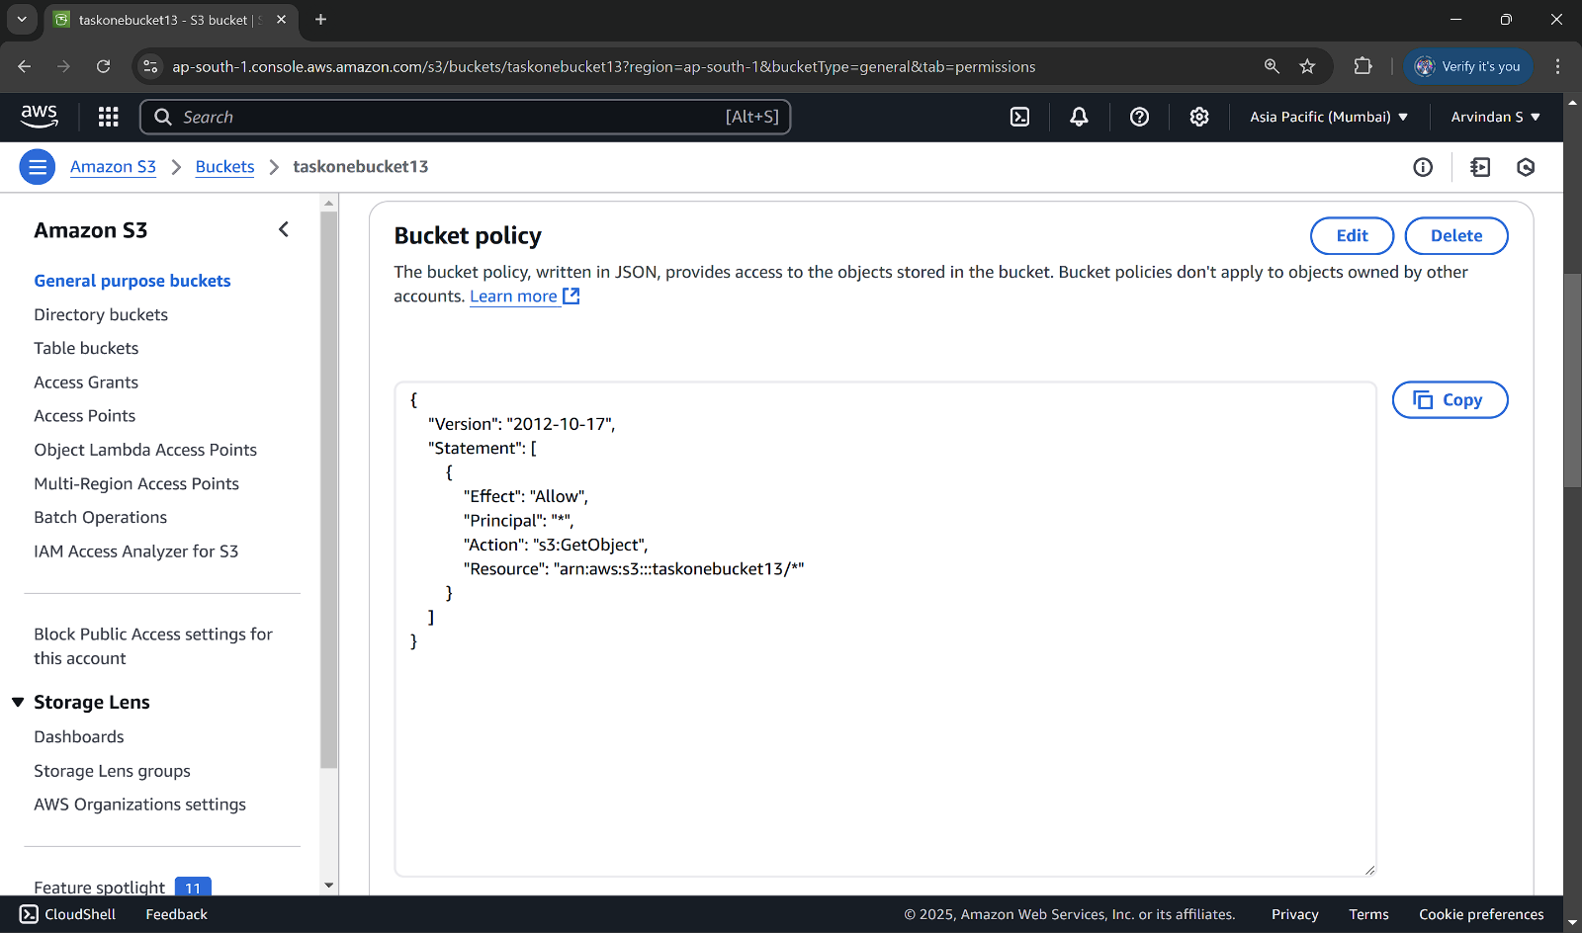

Step10:

Use the S3 bucket URL or public file URL to test access permissions.

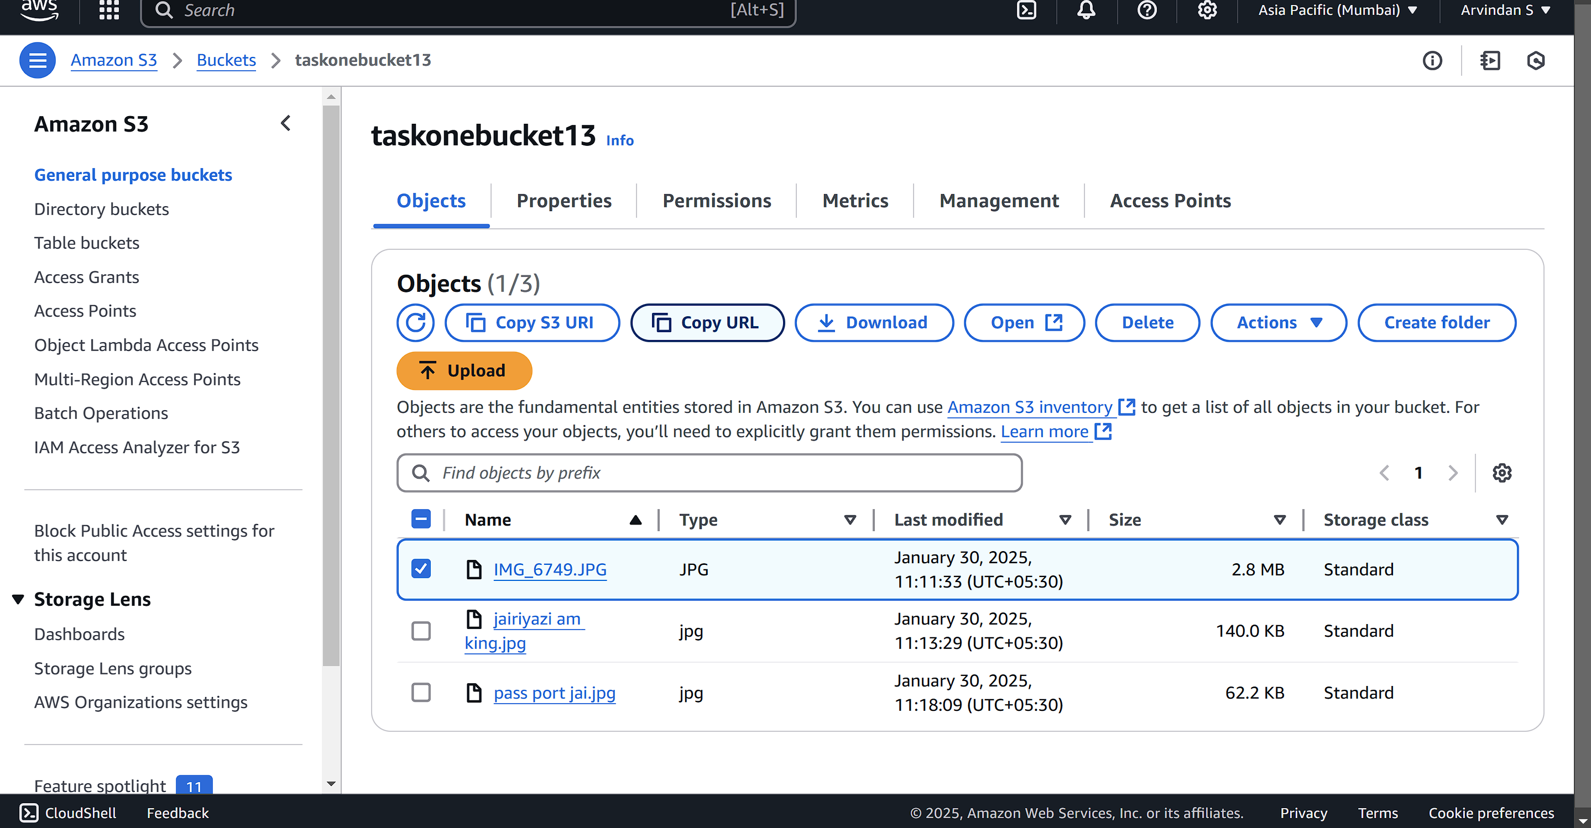

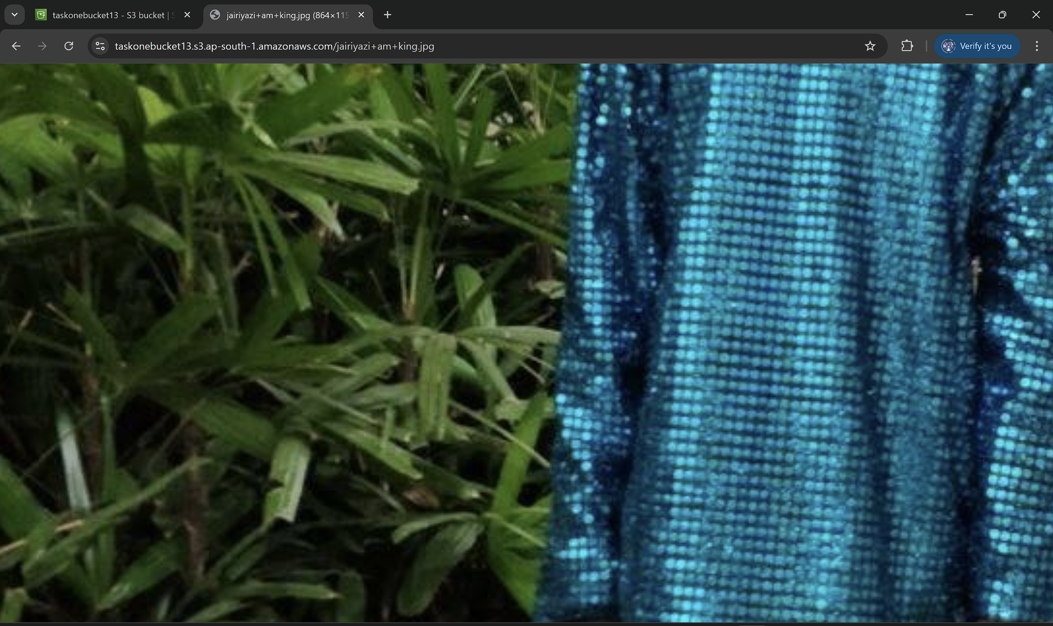

**Expected Outcome**

By completing this POC, you will:

1. Successfully create an AWS S3 bucket and perform file upload/download operations.
2. Configure and validate access permissions, ensuring secure or public access as needed.
3. Gain a solid understanding of S3's functionality, enabling its use in real-world cloud-based applications.